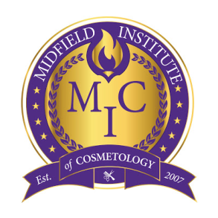
TEXTBOOK
INFORMATION

COSMETOLOGY PROGRAM:

Milady Standard Cosmetology, 13th Edition
Milady: ISBN: 978-1-2857-6941-7
©2016| Publisher: CENGAGE Learning | $121.95

Cosmetology Review Exam, 13th Edition
Milady: ISBN: 9781285769554
©2016| Publisher: CENGAGE Learning| $39.95

Cosmetology Theory Workbook, 13th Edition
Milady: ISBN: 9781285769455
©2016| Publisher: CENGAGE Learning| $49.36

Cosmetology Practical Workbook, 13th Edition
Milady: ISBN: 9781285769479
©2016| Publisher: CENGAGE Learning| $49.36

INSTRUCTOR TRAINING PROGRAM

Milady Master Educator: Student Course Book, 3rd Edition (Letha Barnes)
ISBN13: 9781133693697
©2014| Publisher: CENGAGE Learning| $169.95

Exam Review for Milady’s Master Educator: Student Course Book 3rd Edition ( Letha Barnes)
ISBN13: 9781133776598
©2014| Publisher: CENCAGE Learning| $52.95

